HOMEWORK 2

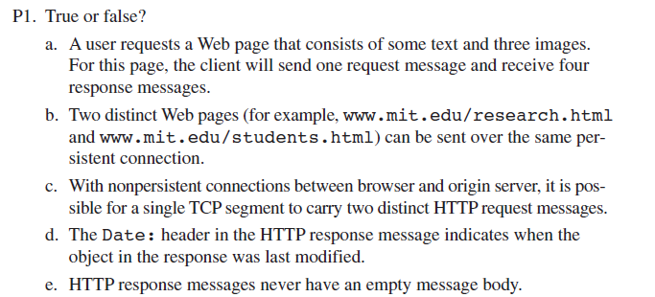

1. False, we need a get message for the text and then each of the images.
2. True because they both come from mit.edu
3. False. Nonpersistent = only 1 req sent
4. False
5. False

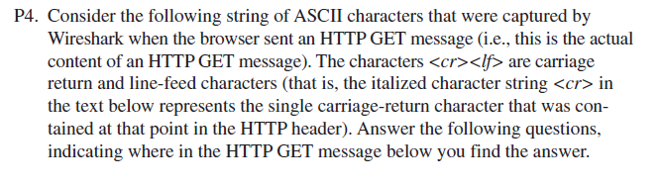

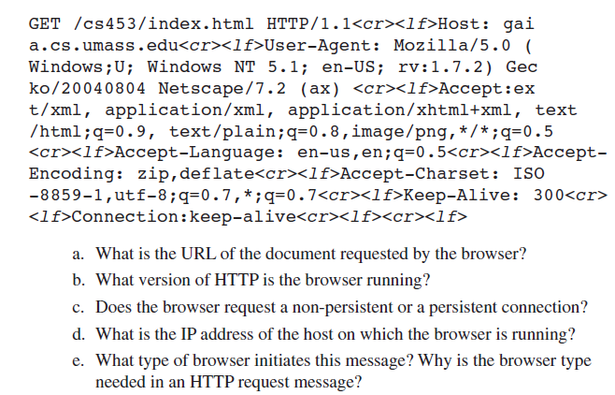

1. URL = gaia.cs.umass.edu/cs453/index.html
2. 1.1
3. Persistent (Keep alive)
4. Cannot be determined
5. Mozilla Firefox is the browser of initiation, browser type is need because we can send the same info different ways to match the formatting of different browsers. To make sure it shows up properly.

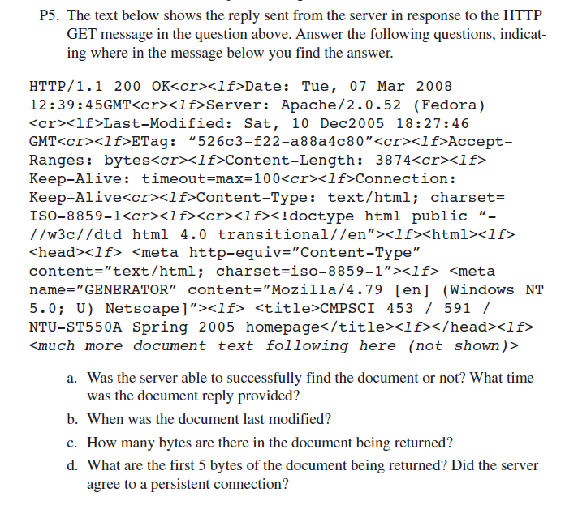

1. Yes, because the message code is 200, and status code is OK. Document reply was 3/7/2008 12:39:45am
2. Last modified: 12/10/2005 at 18:27:46
3. Bytes in doc returned: 3874
4. First 5 bytes: <!doc. Server did not agree to a persistent connection because Keep Alive.

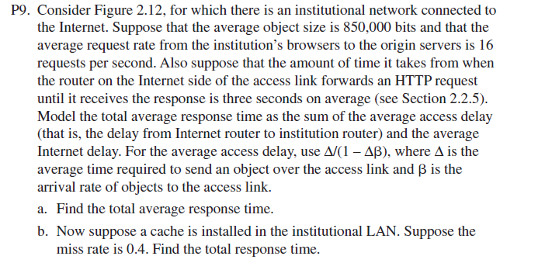

Figure 2.12

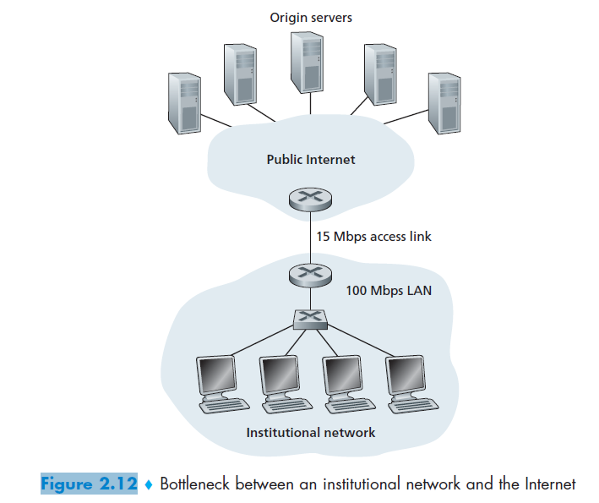

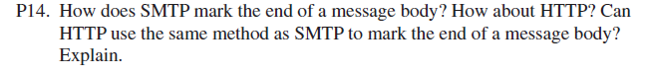

It marks the end with a line containing only a single period. HTTP shows end of message body by checking content length. Can they use the same method? No, because one is in binary (HTTP) and the other in ASCII (SMTP).

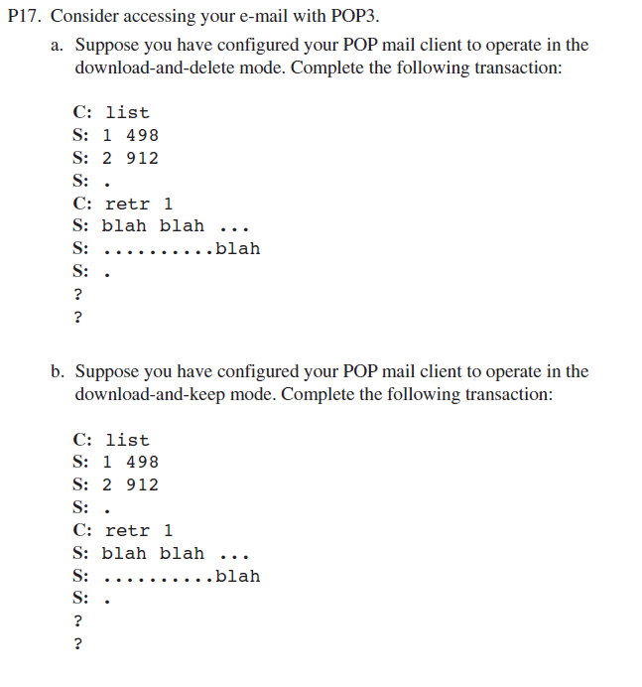

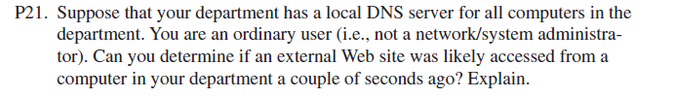

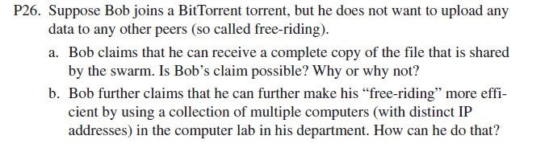

1. Bob cannot be a free rider because in order to gain any priority with which to receive any data, he must eventually have the highest data rate willing to give to another. That is how other people want to share with him, how priority is created.

